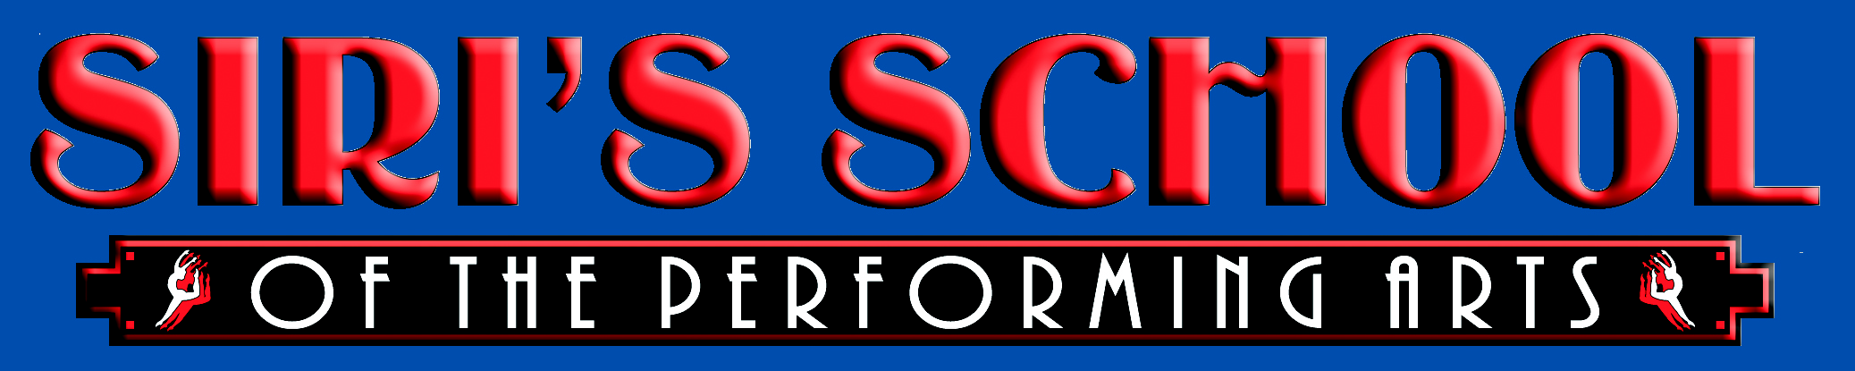

Student Handbook
2022-23 School Year

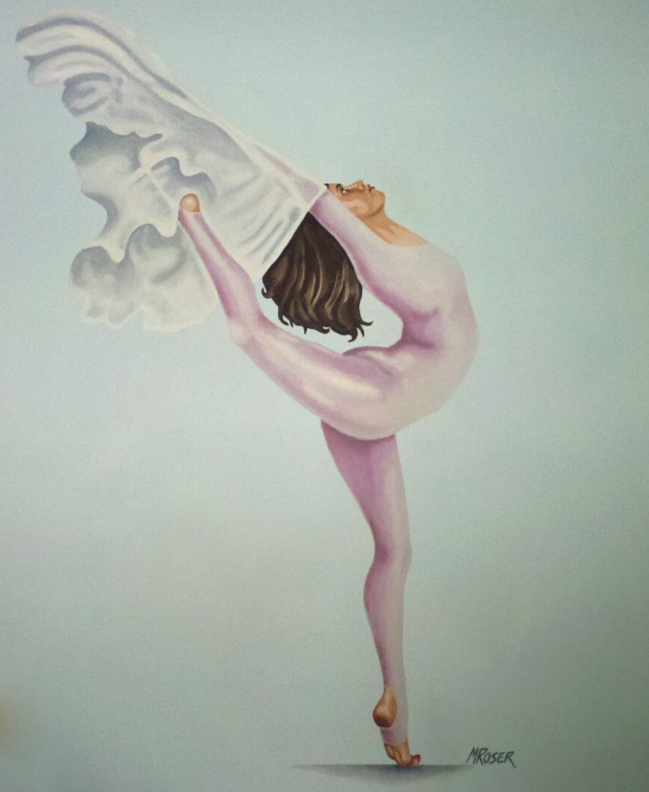

Northgate Plaza
115 Perry Highway, Suite 162
Harmony, PA 16037
(724) 453-0944
www.sirischool.com
Class Options
Pre-School and Kindergarten Classes:
3-4 yrs. Combo Class (Ballet, Tap)
3-6yrs. Tiny Tumblers (acro)
4-5 yrs. Combo Class (Ballet, Tap), Disney Jr (Intro MT)
5-6yrs. Combo Class (Ballet, Tap)
Disney Jr (Intro MT)
6-7yrs. Pre-Dance (Ballet, Tap and Jazz)
Acro, Pre HipHop & MT

All classes are 45 minutes except Tiny Tumblers is a half hour.
Ages 7 and up Classes:
Level 1. Ballet, Tap, Jazz, HipHop, Tumbling/Acro,
Musical Theatre, Acting, Private Voice.

Level 2. Ballet, Tap, Jazz, HipHop, Tumbling/Acro,
Musical Theatre, Lyrical/Contemporary,
Private voice.

Level 3 & 4.. Ballet/Pointe, Tap, Jazz, HipHop, Tumbling/Acro,
Modern, Lyrical/Contemporary, MT, Private
Voice and Dance.

2020-21 Calendar

September 12th Fall Term Begins
October 31st Halloween
November 23rd – November 28th Thanksgiving
December 22nd – January 3rd Holiday Break
January 4th Spring Term Begins
April 3rd – April 9th Spring Break
May 26th – May 30th Memorial Weekend
June TBA Recital Dress Rehearsal
June TBA Student Recital

- Siri’s School of the Performing Arts is not responsible for any injuries that may occur in or around the premises.

- The information in this handbook is subject to change.

WELCOME!

Studio Etiquette
- No Food or Drink allowed in studio’s.
- No chewing gum in class.
- Hair must be pulled away from face. Ballet all hair must be in a bun.
- No talking back or talking while the instructor is talking.
- No hanging or swinging on barres and no feet on walls.
- No playing or screaming in the corridor outside the studio’s.
- No street shoes allowed in the studio.
- Correct dance attire should be worn at all times.
Observation:
Observation week will be December 5th – 10th . Last 10 minutes of all classes can be observed this week. This is the only observation permitted. Parents please observe the same rules that the students are to follow.
Withdrawing from classes:
In order to permanently withdraw from any or all classes, you must fill out and return the Withdrawal form, which is available from the office, thirty days starting the beginning of the month prior to your intended withdrawal. Unless you do so, your account will continue to be active and you are responsible for paying. If you would decide to leave “Siri’s School” in January or after, for any reason at all, you would still be responsible to pay for the remaining months of the year through June.
Refunds and Make Ups:
Private lessons are Non-Refundable and there are no make ups. Absence from classes can be made up during the month of absence, providing there is room in another class and the front desk has been notified.
Costumes:
Sizing of costumes will be the 1st week of January. Costumes are ordered by 3rd week of January. Invoices sent out February 1st. ALL costumes payments are due by March 1st. Costumes are non refundable once ordered, NO EXCEPTIONS!
Dress Requirements:
- Girls: Ballet Black leotard, of any style with pink ballet tights and pink leather or canvas shoes.
- Acro must wear either a biketard or shorts and leotard, NO
T-shirts are allowed.
- Other classes are allowed to wear unitards or leotard, tights and shorts. Shorts are permitted but with tights. NO baggy sweats or t-shirts in class.
- Boys: White T-shirt, navy blue or black sweatpants and shorts are okay.
- Please refer to dance attire and shoe accessories list for all information.
- Students at Siri’s may purchase dancewear from “All that Jazz” in Wexford and receive a 10% discount.
Inclement Weather:
Although classes are rarely cancelled, in case of snow or icy road conditions, you may call the studio 24 hours a day or check our website or Facebook page to get information on cancellations. It will be posted by 3pm. 724-453-0944 or www.sirischool.com
Callboard:
Always remember to check the school callboard for things that are happening, auditions, parties, schedule changes, rehearsals etc.
Attendance:
A minimum attendance standard is required. If a student misses more than 8 classes after December, they WILL NOT be allowed to participate in the year end recital (costumes are on refundable) as this is not fair to other students. Please arrive on time for class(es).
Emails:
Always check your emails for studio information and updates.

Special Events

Christmas Show/Party:
Christmas show /party will be Friday, December 9th 6-8pm.
Bring a Friend:
Every student is allowed to bring one friend to class the week of October 26th – 29th . Friends must observe the same rules as Siri’s School students. If you are bringing a friend they must sign a release form before participating in class for insurance reasons. Age 7 and under can wear Halloween costumes to class this week.
Recital:
Dress rehearsal is June TBA, (which is mandatory for all those participating in the recital) and then the performance is June TBA. (The recital is optional, but strongly advised for performing experience and fun!) These dates will be confirmed by October.
July 4th Parade:
This is open to any of our students who would like to walk the parade and represent the studio. Recital T-shirts are worn with black shorts and tennis shoes. Such a fun day in the sun!

Class Rates
Dance
$55 1st Class (All classes except Lev. 3 & 4
Ballet & MT)
$65 1st Class (Lev.3 & 4 Ballet & MT)

$95 2 Classes

$120 3 Classes

$135 4 Classes

$160 Unlimited Group classes

Group Classes: Ballet. Pointe, Tap, Jazz, HipHop, MT, Acro, Modern, Lyrical/Contmeporary.
These class rates do not include Private voice or Dance Instruction. Private classes are separate.
Private Voice $25 per half hour

Private Dance $30 per ½ hour $45 per ¾ hour
$60 per hour
- Tuition is paid monthly, and is due the first class of each month. If paid after the 10th there is $10 late fee added. Tuition is the same every month regardless of the number of classes, this includes months of December and June. Make checks payable to Siri’s School and write your child’s name on memo or envelope. There is a tuition box on the front desk or you can mail payment to address on front of this handbook.
- There is a $30.00 fee for any returned checks
- If you would decide to leave “Siri’s School” Before January then you must give a 30 day notice at beginning of the month.
- If you would decide to leave “Siri’s School” in January or after, for any reason at all, you would still be responsible to pay for the remaining months of the year through June.
- In the case that this provision would have to be enforced by legal action, the parent/guardian will be responsible for all payments, as liquidated damages, costs of collection, plus interest at the legal rate and reasonable attorney’s fee as determined by the court or 15% of the amount collected failing such determination.

